Recovering Corrupted File from OneDrive Using Version History

An Assignment submitted in partial fulfillment of the requirements for the degree of
Bachelor of Science
in
Computer Science

CS 3306: Databases 2

Term 4 - 2025
University of The People

Instructor: Dr. Afrah Nazir

April 23rd 2026

Recovering Corrupted File from OneDrive Using Version History
When discussing recovery in database systems, I'm reminded of the day my "Quantum Physics" PowerPoint presentation became corrupted just as I stepped into the classroom ready to teach. You can imagine the frustration I experienced when I had already introduced the lesson and learners had written down the learning outcomes, with all their attention focused on me for the lesson content. I quickly had to change my lesson plan to revision and distributed a worksheet with practice questions from a previously covered topic while I figured out how to recover the file. I reached out to friends working in the ICT department, but their suggestions didn't work. My teaching assistant was also distressed and was researching how to recover a corrupted file. My desktop search history was obvious, you can guess, and some suggestions from the search results involved software that charged for the service, which was unreasonable since I needed a one-time solution, not an annual subscription. This doesn't mention the numerous YouTube videos I watched on recovering corrupted files, but all efforts were futile. During this conversation, my teaching assistant asked if I had saved my file in OneDrive, which I admitted I had. He took charge of my desktop, and the next thing I saw was him navigating to OneDrive's file version history. He asked for the file name, and with a click of a button, he was able to restore the previous version of my corrupted file, which was working perfectly. You can imagine my sigh of relief. This is my story about my practical encounter with recovery systems in databases.
A computer system is subject to failure from a variety of causes such as disk crash, power outage, software error, fire, or even sabotage. When failure occurs, information may be lost. The database system must therefore take actions in advance to ensure atomicity and durability transaction properties are preserved. The mechanism that guarantees these properties is called a recovery scheme, which must also ensure high availability, minimizing the time for which the database is unusable after a crash (Silberschatz et al., 2001). There are various types of failure that may occur in a system, each requiring a different approach. Failures fall into two broad categories: failures that do not result in loss of information, which are simpler to handle, and failures that do result in loss of information, which are more difficult to deal with (Silberschatz et al., 2001). I would classify my data loss in the scenario above into the former category. One question I came across when researching OneDrive's file recovery system was “How do I access files in OneDrive that appear to be corrupted?” as cited in Microsoft (2024). Figure 1 shows a screenshot of one Microsoft user's message for this question.
Fortunately, the customer received a response from one of Microsoft's moderators with two methods for recovering the lost file, as shown in Figure 2 (Microsoft, 2024). The first method involved repairing the corrupted file directly using the built-in file recovery feature, which I tried when I encountered the same problem. However, this method didn't work for me. The second method suggested by the moderator was restoring the previous version of the file from OneDrive, which is what my teaching assistant used and successfully managed to recover the lost file. Details on the steps to follow in each method are shown in Figure 2.
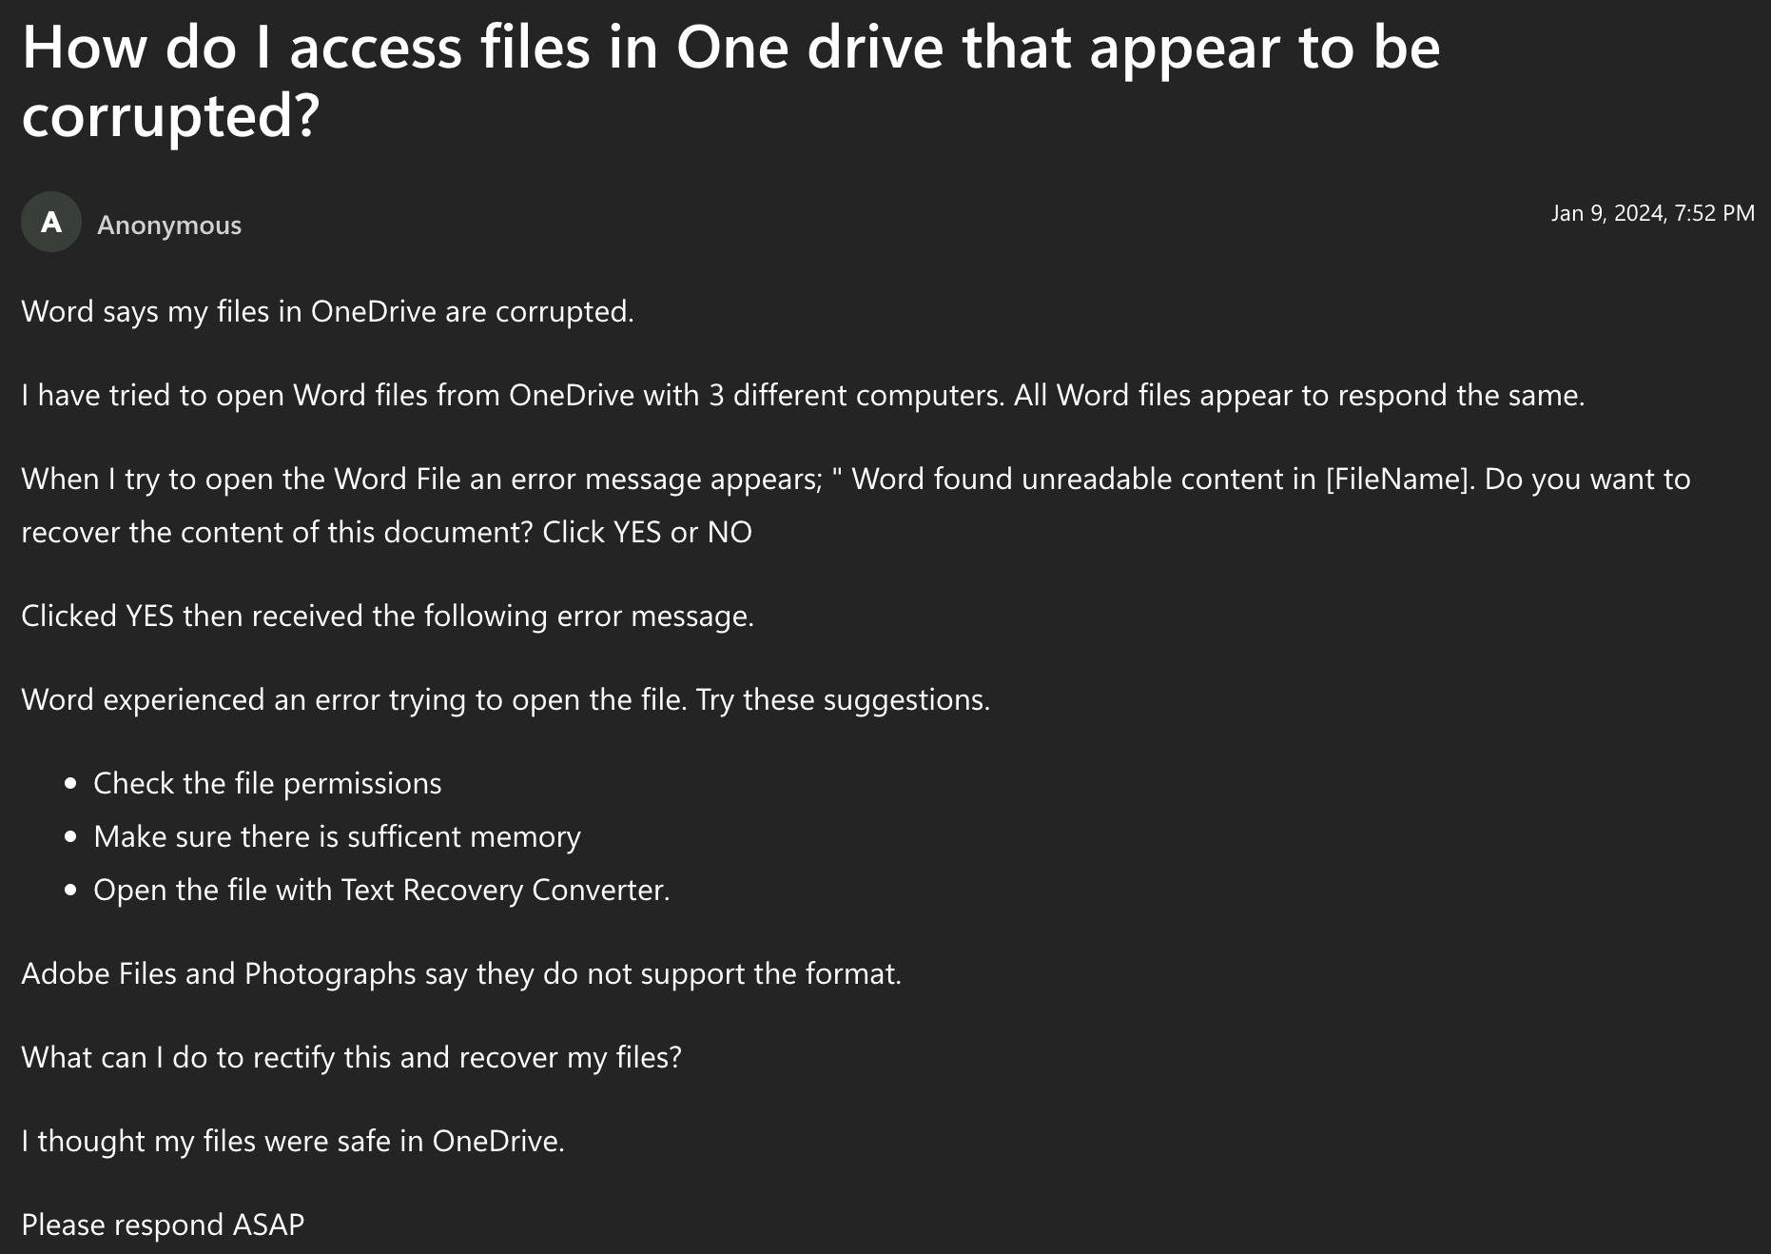Figure 1: Microsoft customer message on corrupted file recovery
Recognizing that customers might experience data loss due to corrupted files, Microsoft provides a guide for users on how to recover a previous version of a file stored in OneDrive using the version history feature. Accessing OneDrive through a web browser or the desktop sync app provides options for restoration. In the web browser, signing in to OneDrive allows users to right-click the desired file and select “Version history.” A pane will then display previous versions, where selecting the ellipses (...) next to the desired version and clicking "Restore" will reinstate that version (Microsoft, 2026). Similarly, using the OneDrive sync app in Windows File Explorer, right-clicking the file and selecting "Version history" leads to the same restoration options. OneDrive retains multiple versions, but the number depends on the account type and administrative settings (Microsoft, 2026). Restoring a previous version overwrites the current one, with the overwritten version becoming the immediate prior version in the history.
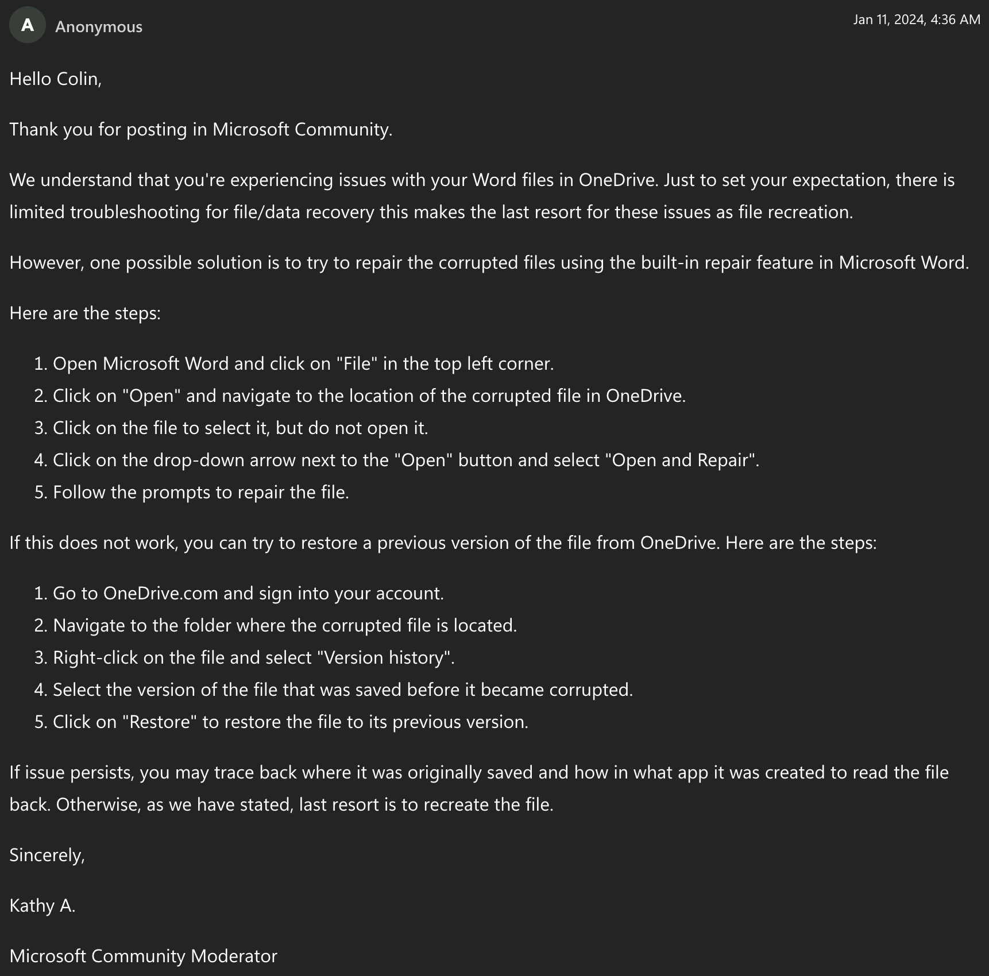Figure 2: Microsoft moderator suggestions on methods to recovery corrupted files
Although recovering previous versions of files from OneDrive can be a useful feature, it's important to be aware of certain precautions. The number of versions available for recovery depends on the type of Microsoft account used. Personal accounts allow retrieval of the last 25 versions, while work or school accounts are subject to library configuration (Microsoft, 2026). Additionally, if OneDrive is used as part of SharePoint Server, document versioning may be disabled by the administrator. When recovering files from the recycle bin, personal accounts automatically delete items after 30 days, or three days if the recycle bin is full. Work or school accounts retain items for 93 days, unless the administrator has altered the setting (Microsoft, 2026). Understanding these limitations ensures a smoother and more effective file recovery process.
In conclusion, my experience with OneDrive's file recovery system demonstrates the critical importance of robust backup and recovery mechanisms in modern database systems. The seamless restoration of my corrupted PowerPoint presentation through OneDrive's version history feature exemplifies how cloud-based storage solutions have evolved to address the fundamental challenges of data loss that database systems have long grappled with. This practical encounter highlights the real-world application of database recovery system I have learnt this week, where ensuring atomicity and durability properties is paramount for maintaining data integrity. As our society becomes increasingly dependent on digital information storage, the ability to quickly and effectively recover from data corruption or loss scenarios becomes not just a technical necessity but a crucial component of business continuity and educational delivery. Microsoft’s OneDrive represents just one example of how modern backup and recovery software has transformed abstract database recovery concepts into user-friendly tools that protect against the inevitable failures that occur in computer systems, ultimately ensuring that our digital assets remain accessible and secure even when unexpected corruption events occur.
References
Microsoft. (2024, January 9). How do I access files in one drive that appear to be corrupted? Microsoft Learn: Build with answers in reach. https://learn.microsoft.com/en-us/answers/questions/5276340/how-do-i-access-files-in-one-drive-that-appear-to
Microsoft. (2026). Restore a previous version of a file stored in OneDrive. Microsoft Support. https://support.microsoft.com/en-us/office/restore-a-previous-version-of-a-file-stored-in-onedrive-159cad6d-d76e-4981-88ef-de6e96c93893
Silberschatz, A., Korth, H.F., & Sudarshan, S. (2001). Database System Concepts (4th ed.). New York, NY: McGraw-Hill.

